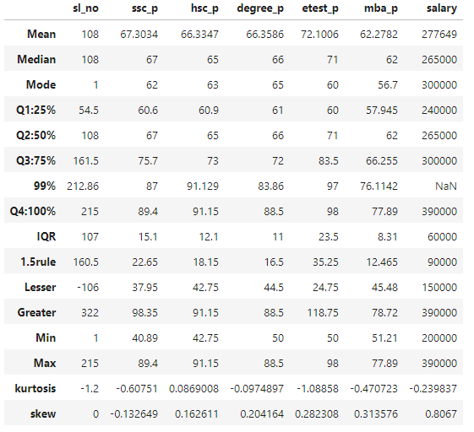

**Skewness**

* **Skewness** measures the asymmetry of the data distribution. A skewness value can tell us whether the data is skewed to the left (negative skew) or to the right (positive skew).

**Columns and Skewness Values:**

1. **SSC (10th Grade Percentage):** -0.132649
   * **Inference:** Slightly negatively skewed, meaning the left tail (lower scores) is longer, and most students scored above the mean.
2. **HSC (12th Grade Percentage):** 0.162611
   * **Inference:** Slightly positively skewed, meaning the right tail (higher scores) is longer, and most students scored below the mean.
3. **Degree (Undergraduate Percentage):** 0.204164
   * **Inference:** Positively skewed, indicating that the distribution has a longer right tail, with more students scoring lower than the mean.
4. **Etest_p (Entrance Exam Percentile):** 0.282308
   * **Inference:** Positively skewed, suggesting that a greater number of students scored below the mean, with a longer tail on the right.
5. **MBA Percentage:** 0.313576
   * **Inference:** Positively skewed, with more students scoring lower than the mean, and a longer right tail.
6. **Salary:** 0.8067
   * **Inference:** Moderately positively skewed, indicating that most students have salaries below the mean, but a few have much higher salaries, extending the right tail.

**Kurtosis**

* **Kurtosis** measures the "tailedness" of the data distribution. It tells us whether the data has heavy tails (leptokurtic) or light tails (platykurtic) compared to a normal distribution.

**Columns and Kurtosis Values:**

1. **SSC (10th Grade Percentage):** -0.60751
   * **Inference:** Platykurtic (negative kurtosis), meaning the distribution is flatter than a normal distribution, with lighter tails and fewer outliers.
2. **HSC (12th Grade Percentage):** 0.086908
   * **Inference:** Nearly mesokurtic, meaning it has a kurtosis close to that of a normal distribution, indicating a relatively balanced distribution with moderate tails.
3. **Degree (Undergraduate Percentage):** -0.0974897
   * **Inference:** Slightly platykurtic, suggesting a flatter distribution with lighter tails, similar to SSC.
4. **Etest_p (Entrance Exam Percentile):** -1.08858
   * **Inference:** Platykurtic, meaning the distribution is flatter with light tails, implying fewer extreme values.
5. **MBA Percentage:** -0.470723
   * **Inference:** Platykurtic, indicating a flatter distribution with fewer outliers and lighter tails compared to a normal distribution.
6. **Salary:** -0.239837
   * **Inference:** Slightly platykurtic, suggesting that the salary distribution is relatively flat, with lighter tails, but still potentially influenced by a few outliers.

**Overall Inference:**

* **Skewness:**
  + Most of the data columns have positive skewness, indicating that they are right-skewed. This means that in general, most students have scores below the mean, but there are a few higher scores that stretch the tail to the right.
  + The salary column shows the highest positive skewness, indicating a significant number of students earn below the mean salary, but a few have much higher salaries.
* **Kurtosis:**
  + The negative kurtosis values (platykurtic) for most columns, especially SSC, Etest_p, and MBA, indicate that these distributions are flatter with lighter tails, implying fewer extreme outliers.
  + The salary data also shows a slightly negative kurtosis, suggesting that while there may be some high outliers, the overall distribution is relatively flat and lacking in extreme values.